**How to Launch an Amazon AWS EC2 Instance**

1. Login to your AWS Console and select the EC2 Service. It launches the EC2 dashboard. The dashboard shows the current running instances, the available elastic IPs, volumes, snapshots and other details. Click on **“Launch Instance”** to launch the EC2 instance.

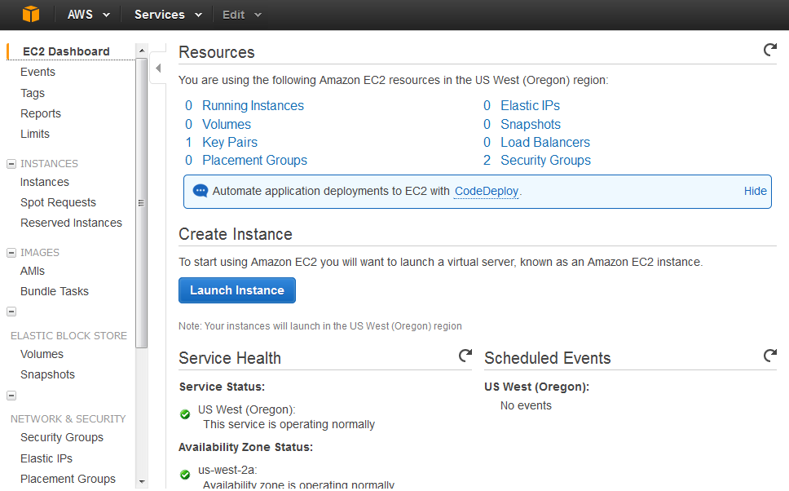

**2.** Select the AMI. The AWS Launch screen provides multiple options to select AMI. The user can select the AMIs provided by AWS (Standard OS)., Select “My AMIs” to launch the instance from the user’s existing AMIs or select community AMIs to launch the instance from various providers (may or may not be

authorized by AWS).

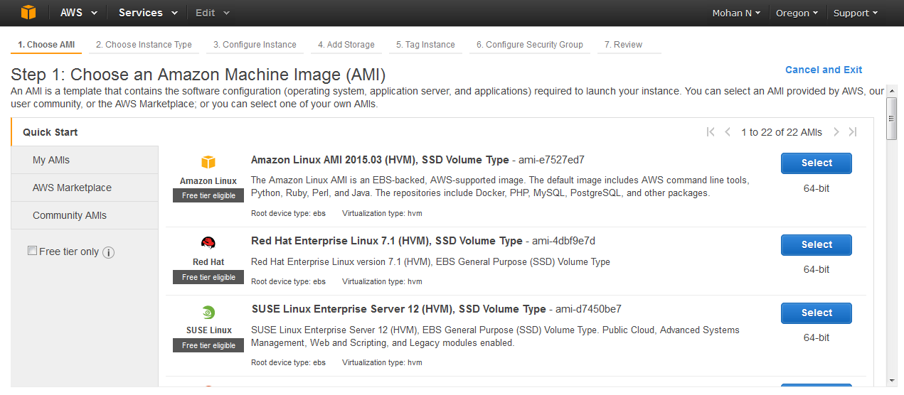

**3.** The various instance types are shown in the figure given below. Select the t2 Micro and click on the

“Next configuration setting” button.

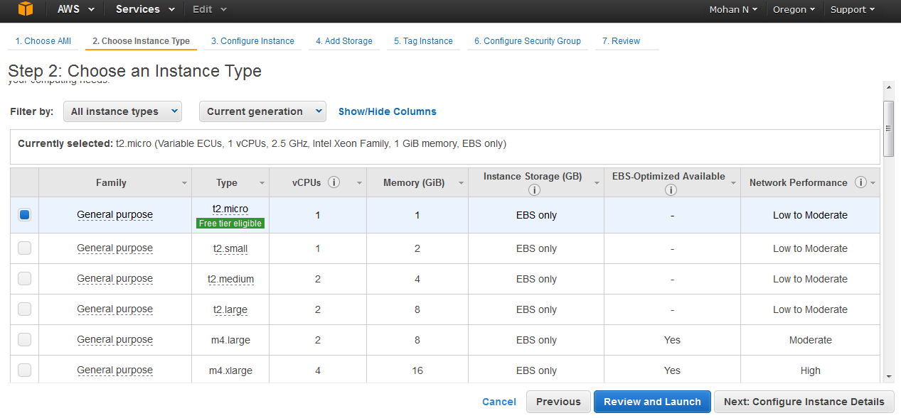

**4.** Provide IAM role None and click on Next:Add Storage.

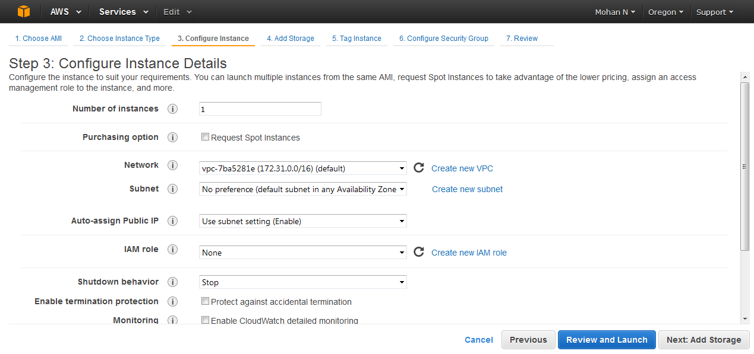

**5.** Provide the storage related information. Click on “Add New Volume” to Add new Volume and can Delete by Cross button.

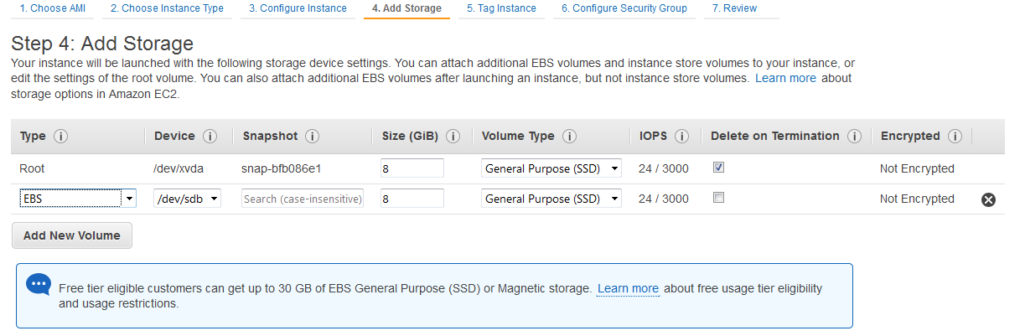

**6.** Provide the Root Volume Size (cannot be less than 8 GB for Linux) and Volume Type Standard.

**7.** Provide the tags for the AWS instance. Tagging is very useful when the user wants to track the cost of a particular instance / service.

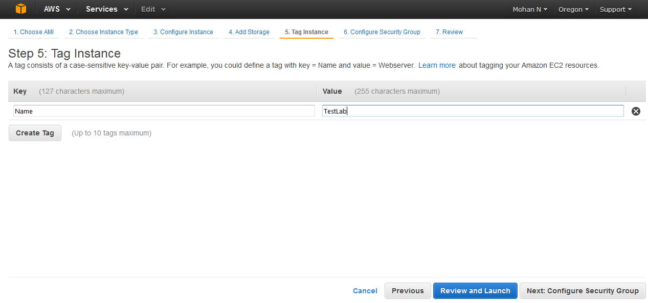

**8.** For the security of the instance, select the existing key-pair.

For Existing Key-Pair

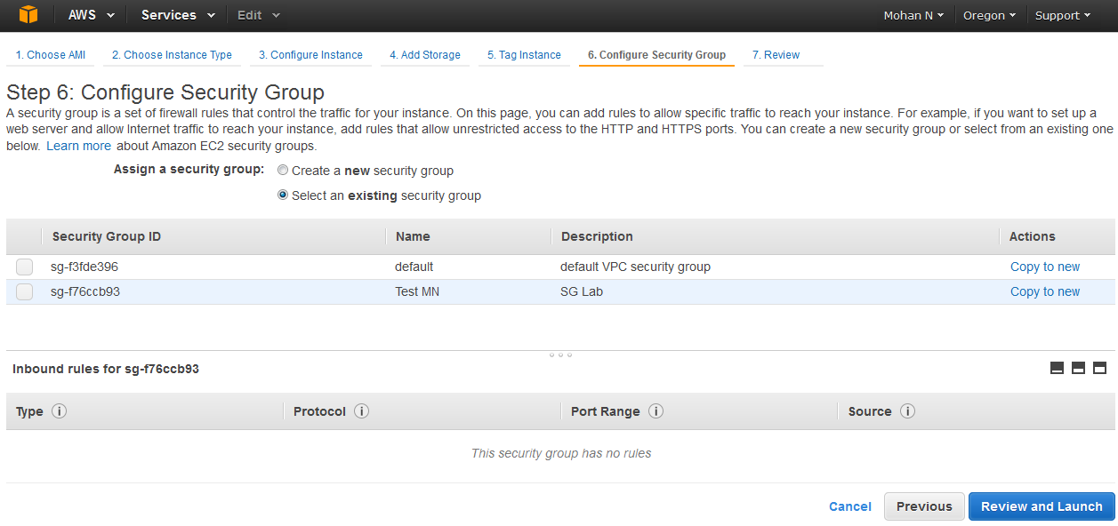

**9.** Select the security group. The security group provides the virtual firewall for the user’s instance. Open

only the ports for the specific IPs as per the user’s requirement. Click on “Review and Launch”.

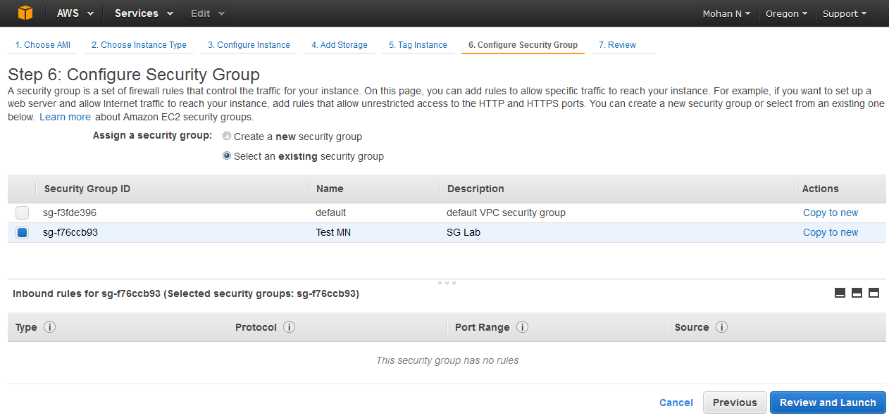

**10.** Review all the details and click on “Launch”.

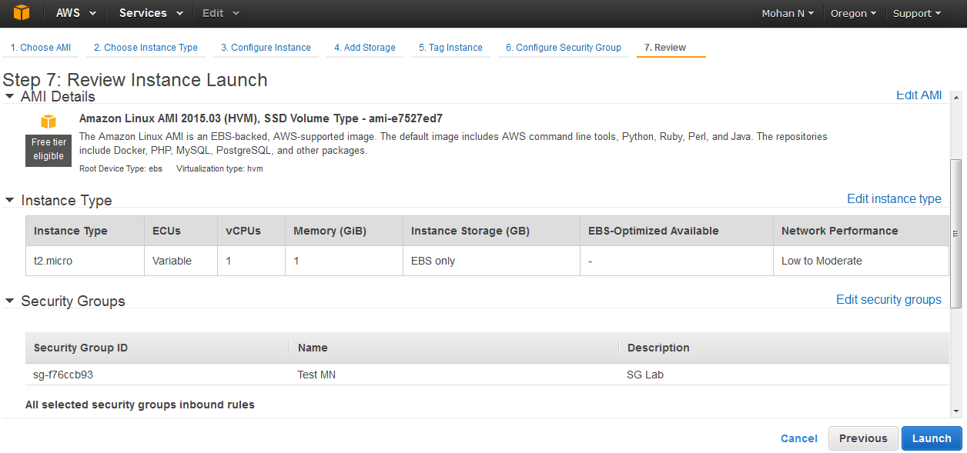

**11.** AWS will launch the instance and provide the user with the ID of the instance.

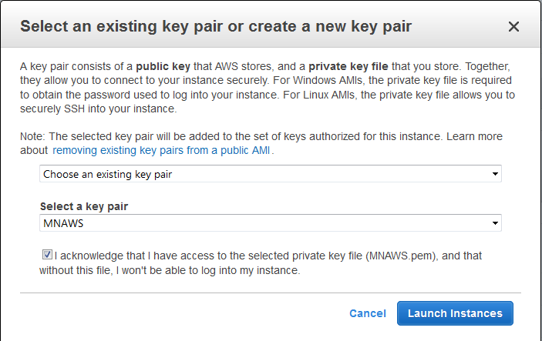

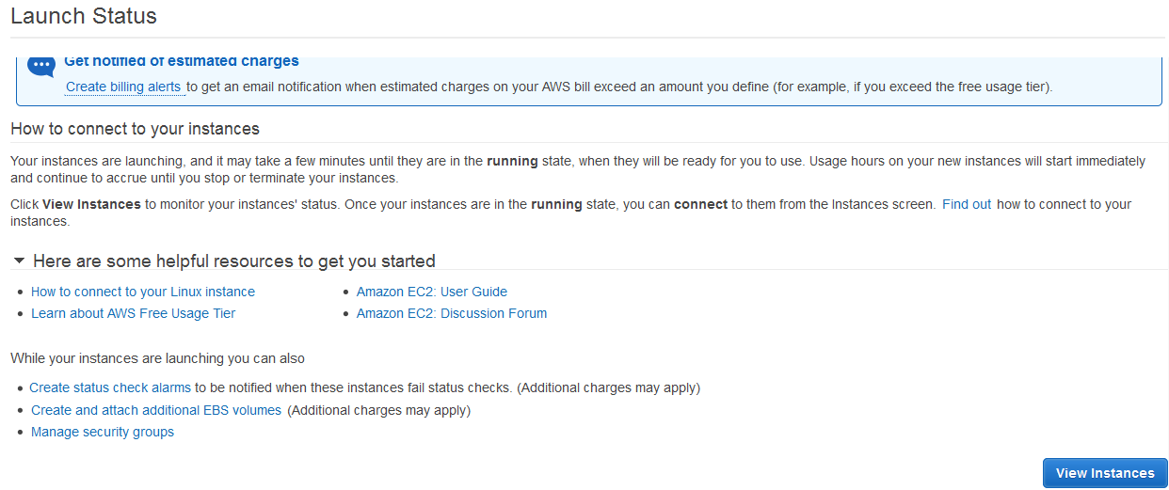

**12.** Go to the AWS EC2 console and it will display the new instance. The instance will be first in a running

State. It is advisable to connect to the instance once the status checks are in “2/2 Checks”.

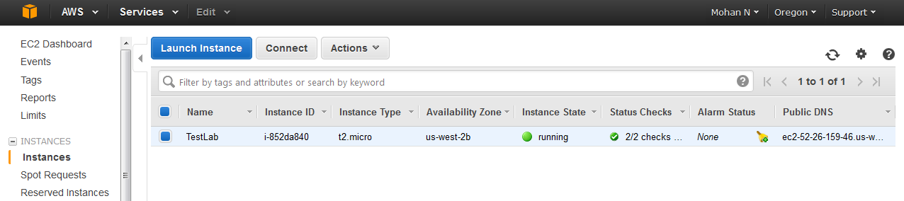

**13**. Previously, it was showing 0 running instance on EC2 Dashboard. Now it is showing running instance

1.

